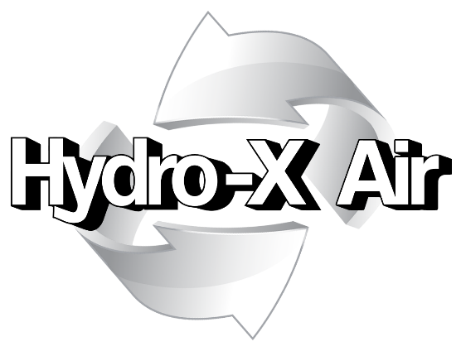

Firestopping Report No:

7742661

CBRE GWS Ltd

At
One Creechurch Place

INDEX

 | Section
Preface | 1
Introduction | 2
Photographic Evidence | 3
Certification | 4

Section 1: Preface

Customer: | CBRE GWS Ltd
Hydro-X Account Manager: | Dave Stewart
Account Manager Telephone Number: | 07795 692238
Account Manager Email Address: | Dave.stewart@hydro-x.co.uk
Hydro-X Address: | Hydro-X Air Ltd  The Maylands Building  Maylands Avenue  Hemel Hempstead  HP2 7TG
Hydro-X Telephone Number: | 01909 565133
Hydro-X Email Address: | info@hydro-x.co.uk
Hydro-X Operatives Carrying Out Works: | George Bainbridge
Date of Assessment: | 22/05/2021

Any further information concerning this assessment should be requested by contacting the above-named Hydro-X Account Manager.

Section 2: Introduction

Hydro-X Air Ltd were instructed to undertake the repairs of the firestopping at One Creechurch Place. The works were completed on 22 May 2021.

Section 3: Photographic Evidence

4th Floor Server Room Fire Barrier Pre:
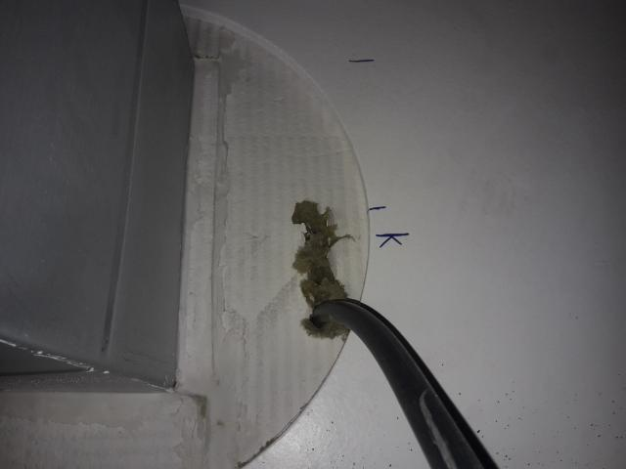
4th Floor Server Room Fire Barrier Post:
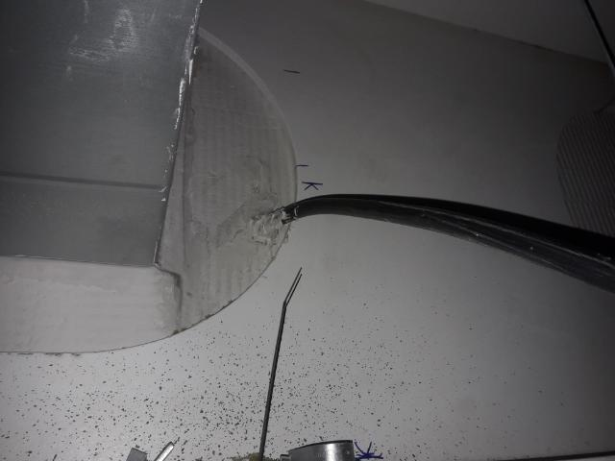

4th Floor Tea Point 1 Corridor Fire Barrier Pre:
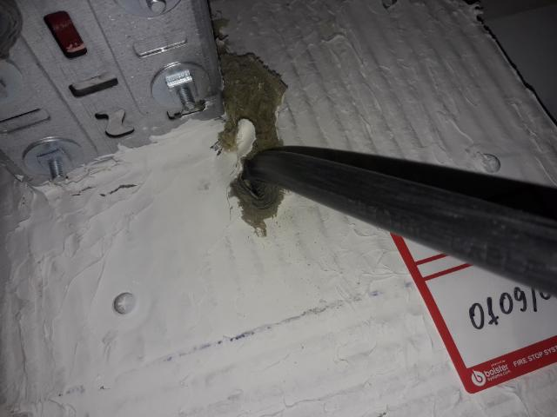
4th Floor Tea Point 1 Corridor Fire Barrier Post:
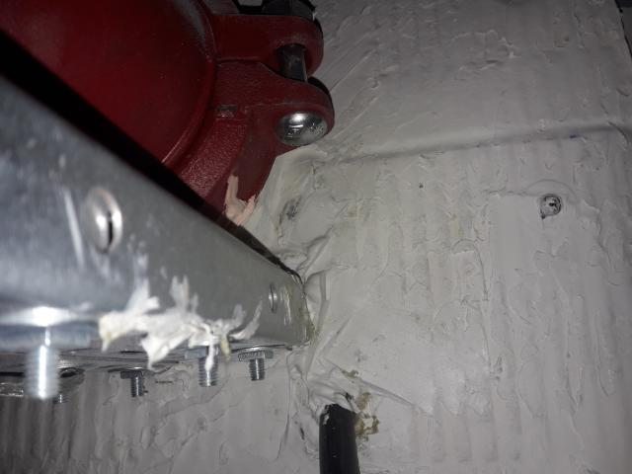

4th Floor Riser Core Door D.04.32 Fire Barrier Pre:
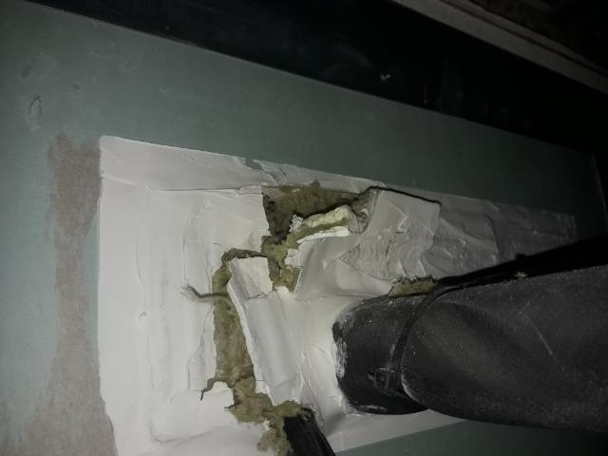
4th Floor Riser Core Door D.04.32 Fire Barrier Post:
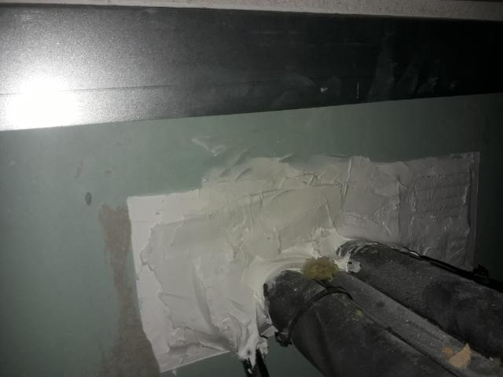

4th Floor Riser Core Door D.04.32 Fire Barrier Pre:
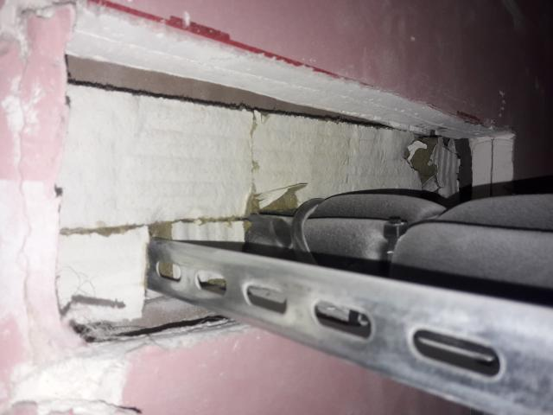
4th Floor Riser Core Door D.04.32 Fire Barrier Post:
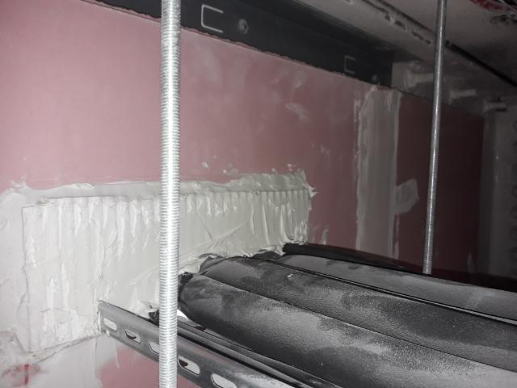

3rd Floor Riser D.03.01 Fire Barrier Pre:
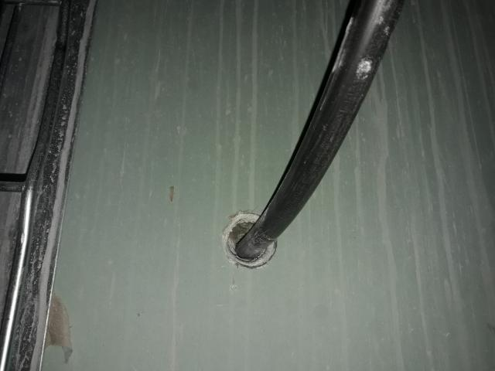
3rd Floor Riser D.03.01 Fire Barrier Post:
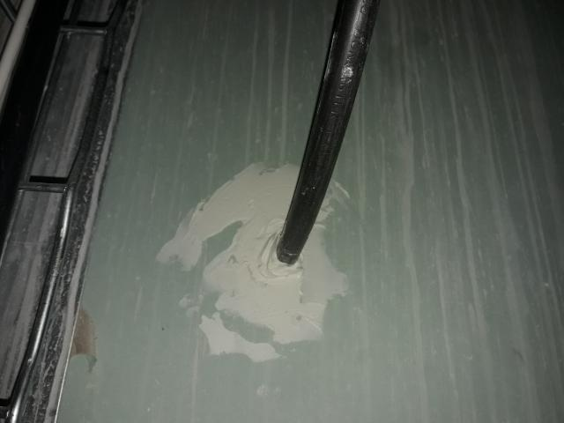

3rd Floor Server Room Fire Barrier Pre:
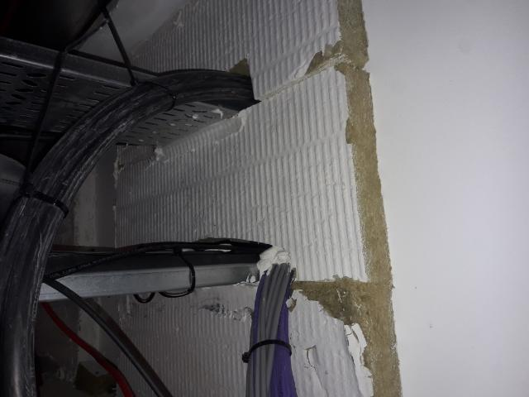
3rd Floor Server Room Fire Barrier Post:
